web technologe

HTML File

BCA 2nd Sam.

**Practical – 01**

**Create a web page using an ordered list and an unordered list. :**

<!DOCTYPE html>

<html lang="en">

<head>

<title>Document</title>

</head>

<body>

<h2>List of Holidays (Unordered List)</h2>

<ul>

<li>14 January Tuesday Makar Sankranti

<li>23 January Thursday Parakram Diwas

<li>26 January Sunday Republic Day

<li>14 March Friday Holi

<li>11 April Friday Mahavir Jayanti

<li>21 April Monday Easter Monday

<li>15 August Friday Independence Day

<li>14 September Sunday Hindi DIwas

<li>22 September Monday Navratri

<li>2 October Thursday Gandhi Jayanti

<li>21 October Tuesday Diwali

<li>5 November Wednesday Guru Nanak Jayanti

<li>14 November Friday Children's Day

<li>27 November Thursday Thanksgiving Day

<li>25 December Thursday Christmas

</ul>

<br>

<h2>List of Special Days (ordered List)</h2>

<ol>

<li>26-Jan  Republic Day</li>

<li>04-Feb  World Cancer Day</li>

<li>08-Mar  International Women's Day</li>

<li>22-Apr  World Earth Day</li>

<li>17-May  World Telecom Day</li>

<li>05-Jun  World Environment Day</li>

<li>29-Jul  International Tiger Day</li>

<li>15-Aug  Independence Day</li>

<li>13-Sep  International Programmers' Day</li>

<li>16-Oct  World Food Day</li>

<li>05-Nov  World Tsunami Day</li>

<li>01-Dec  World AIDS Day</li>

</ol>

</body>

</html>

**Output :**

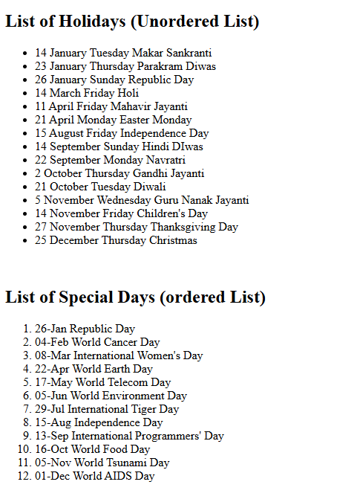

**Practical - 2**

**Design a web page to show your institute with hyperlink. :**

<!DOCTYPE html>

<html lang="en">

<head>

<title>Document</title>

<style>

#div1{

display: flex;

justify-content: space-between;

}

</style>

</head>

<body>

<img src="https://cdn.prod.website-files.com/6595ee355a0f462797ab252b/65b7b458bd880d4014cb3d3f_budhalogo.svg " style="height: 50px;">

<br>

<br>

<nav>

<a href="https://www.budhacollege.edu.in/about-us">About Us</a><br>

<a href="#">Courses</a><br>

<a href="https://www.budhacollege.edu.in/admissions">Admission</a>

</nav>

<br>

<div id="div1">

<div>

<h1>About Us</h1>

<p>All eyes are on India right now, And there’s a big need for skilled professionals.</p>

<pre style="font-family: Arial, Helvetica, sans-serif;">

In an era where India is poised for unprecedented growth, Budha Group of Institutions

stands at the forefront,redefining education to meet the demands of tomorrow.

We understand the gap between traditional education and the skills required in the real world.</pre>

<br>

<h1>Courses</h1>

<ol>

<li><h3>Budha College Of Education</h3>

</ol>

<ul>

<li>Bachelor of Education (B.Ed)

<li>Diploma in Elementary Education (D.El.Ed.)

<li>Bachelor of Commerce (B.Com)

</ul>

<ol start="2">

<li><h3>Budha College Of Management</h3>

</ol>

<ul>

<li>Bachelor of Business Administration (BBA)

<li>Master of Business Administration (MBA)

<li>Bachelor of Computer Applications (BCA)

</ul>

<ol start="3">

<li><h3>Budha College Of Design</h3>

</ol>

<ul>

<li>Bachelor of Fashion Design (BFD)

<li>Bachelor's in Interior Design (BID)

<li>Bachelors in Fine Arts (BFA)

</ul>

<ol start="4">

<li><h3>Pearson BTEC International</h3>

</ol>

<ul>

<li>Pearson BTEC Management

<li>Pearson BTEC Fashion Design

<li>Pearson BTEC Fine Arts

</ul>

<br>

<footer>

<h1>Contact Us</h1>

<b>Address :</b> <Address> Main Campus<br>

<a href="https://www.google.com/maps/place/Budha+College+of+Education/@29.7893125,77.0001875,17z/data=!3m1!4b1!4m6!3m5!1s0x390e6f52b8f6b26d:0x2a44631374ecd663!8m2!3d29.7893125!4d77.0001875!16s%2Fg%2F11c585vkzl?entry=ttu&g_ep=EgoyMDI1MDQxNi4xIKXMDSoASAFQAw%3D%3D">Indri Road, SH 7, Ramba, Karnal, Haryana 132001</a><br><br>

Design Campus<br>

<a href="https://www.google.com/maps/place/Budha+College+of+Architecture/@29.7868962,76.998012,17z/data=!3m1!4b1!4m6!3m5!1s0x390e6f4d9cecb6a5:0x78274b9bbe6e289e!8m2!3d29.7868962!4d76.998012!16s%2Fg%2F1hf6n12ys?entry=ttu&g_ep=EgoyMDI1MDQxNi4xIKXMDSoASAFQAw%3D%3D"> QXPX+Q62, SH 7, Haryana 132001</a></Address><br>

<b>Email :</b> <a href="mailto: hello@budhacollege.org">hello@budhacollege.org</a><br>

<b>Phone :</b> <a href="tel:+91 9996013805">+91 9996013805</a>

</footer></div>

<div><img src="C:\Users\acer\Downloads\budha-college-of-architecture-karnal-260424.jpg" alt="Image" style="height: 750px;"></div>

</div>

</body>

</html>

**Output :**

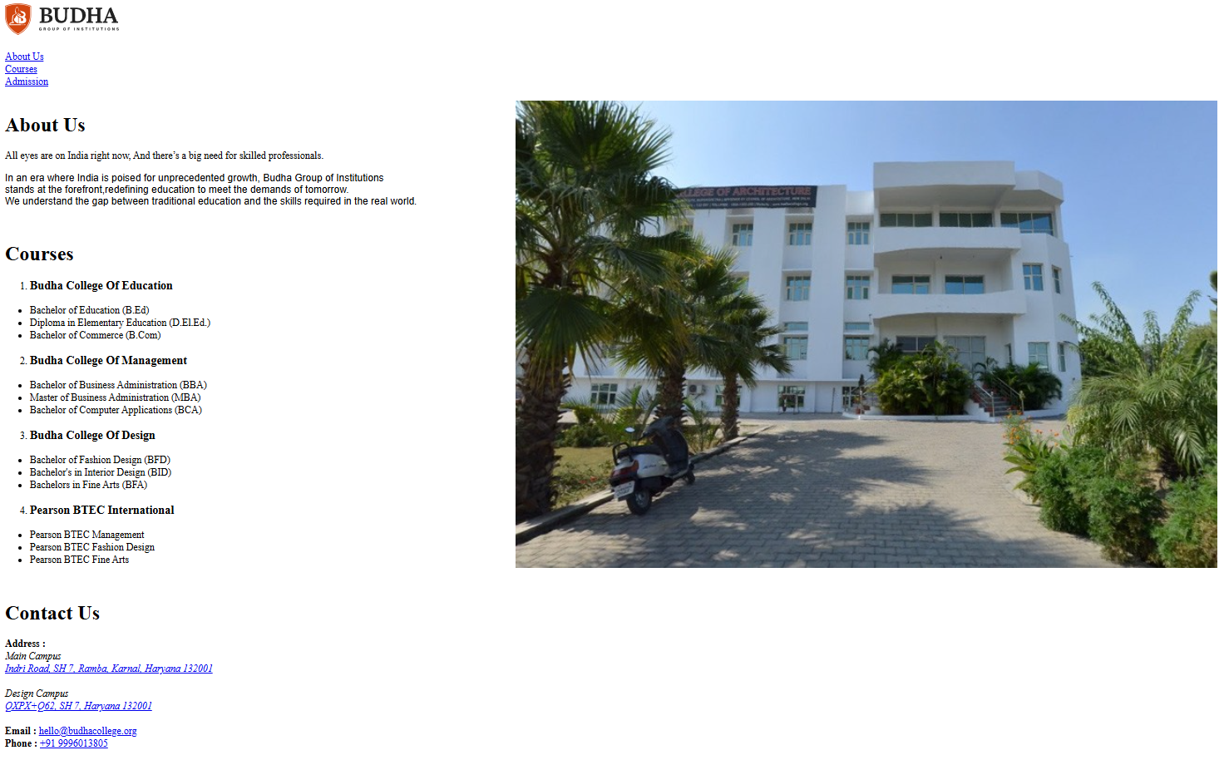

**Practical - 03**

**Create your resume on an HTML page. :**

**<!DOCTYPE html>**

**<html lang="en">**

**<head>**

**<title>Document</title>**

**<style>**

**body{**

**background-color: rgba(250, 232, 199, 0.432);**

**}**

**\*{**

**font-family: Arial, Helvetica, sans-serif;**

**}**

**#img{**

**width: 150px;**

**height: 150px;**

**margin-left: 640px;**

**/* margin-top: 30px; */**

**}**

**h1{**

**margin-left: 605px;**

**}**

**#ul1{**

**list-style: none;**

**display: flex;**

**margin-left: 570px;**

**gap: 14px;**

**margin-top: -5px;**

**}**

**#img1{**

**width: 28px;**

**height: 28px;**

**}**

**#img2{**

**width: 28px;**

**height: 28px;**

**}**

**#img3{**

**width: 30px;**

**height: 30px;**

**}**

**#img4{**

**width: 30px;**

**height: 30px;**

**}**

**#img5{**

**width: 26px;**

**height: 26px;**

**}**

**section{**

**margin-left: 440px;**

**}**

**#h2{**

**background-color: rgba(237, 203, 130, 0.9);**

**display: inline;**

**}**

**fieldset{**

**border-color: rgba(206, 175, 131, 0.781);**

**margin-top: 30px;**

**/* border: none; */**

**}**

**</style>**

**</head>**

**<body>**

**<fieldset style="margin-left: 200px ; margin-right: 750px; ">**

**<div>**

**<img src="C:\Users\acer\Desktop\Developer\photos\me.png" alt="Profile" id="img">**

**<h1>Gitesh Kumar</h1>**

**<ul id="ul1">**

**<li><a href="https://github.com/Giglo01/Project-1"><img src="https://img.icons8.com/?size=64&id=3tC9EQumUAuq&format=png" alt="Github" id="img1"></a></li>**

**<li><a href="www.linkedin.com/in/gitesh-kumar-83772a359"><img src="https://img.icons8.com/?size=48&id=13930&format=png" alt="Linkedin" id="img2"></a></li>**

**<li><a href="mailto:giteshneg5@gmail.com"><img src="https://img.icons8.com/?size=48&id=19408&format=png" alt="Mail" id="img3"></a></li>**

**<li><a href="https://wa.link/s613t2"><img src="https://img.icons8.com/?size=48&id=16713&format=png" alt="Whatsaap" id="img4"></a></li>**

**<li><a href="tel:8219569378 "><img src="https://img.icons8.com/?size=48&id=ufkkYBXJSuPy&format=png" alt="Phone" id="img5"></a></li>**

**</ul></div>**

**<br>**

**<br>**

**<br>**

**<section>**

**<h2 id="h2">Career Objective :</h2>**

**<pre> "Highly motivated student seeking a [Internship/Position] in [Industry/Field]**

**to apply my strong analytical skills and passion for [Specific Area] to contribute**

**to the team's success."</pre>**

**<h2 id="h2">Academic Qualification :</h2>**

**<ul>**

**<li>10<sup>th</sup>passed from CBSE Board in 2019</li>**

**<li>12<sup>th</sup> passed from HP Board in 2021</li>**

**<li>I have done 1 year Advance Computer Course</li>**

**<li>Pursuing Graduation B.C.A from Budha Group Of Institution</li>**

**</ul>**

**<h2 id="h2">Personal Skill :</h2>**

**<ul>**

**<li>Good Communication</li>**

**<li>Teamwork</li>**

**<li>Basic Programming (HTML, CSS, C, C++)</li>**

**<li>Basic Computer Knowledge</li>**

**</ul>**

**<h2 id="h2">Strength and Weakness :</h2>**

**<ul>**

**<li>Tailor to the job</li>**

**<li>Show your self-awareness</li>**

**<li>Be honest</li>**

**<li>Show initiative</li>**

**</ul>**

**<h2 id="h2">Declaration :</h2>**

**<pre> I, Gitesh Kumar, hereby declare that the information provided in this resume is true and**

**accurate to the best of my knowledge and belief.**

**Karnal, Haryana**

**<b>Date :</b> 23 Apr, 2025**

**<b>Your Signature</b>**

**</pre>**

**</section>**

**</fieldset>**

**</body>**

**</html>**

**Output :**

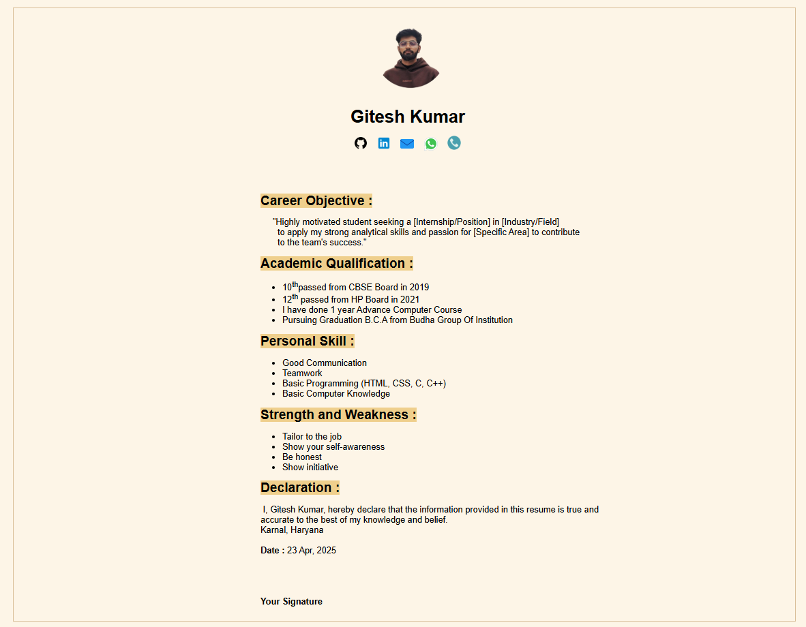**Practical : 04**

**Create a web page and divide the web page into four frames. In one frame create three links that will display different HTML forms in the remaining three frames respectively. :**

1 :

<!DOCTYPE html>

<html lang="en">

<head>

<title>Document</title>

</head>

<body>

<ol>

<li><a href="C:\Users\acer\Desktop\Developer\skills.html">Form</a></li>

<li><a href="C:\Users\acer\Desktop\Developer\Gitesh.html">Portfolio</a></li>

<li><a href="C:\Users\acer\Desktop\Developer\index.html">Netflix</a></li>

</ol>

</body>

</html>

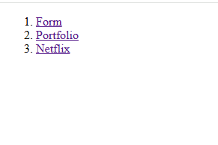

2 :

<!DOCTYPE html>

<html lang="en">

<head>

<title>Cars Landing Page</title>

</head>

<body>

<header>

<h1>Welcome to Car World</h1>

<p>Explore the best cars in the world</p>

</header>

<section>

<h2>About Cars</h2>

<p>Cars have revolutionized transportation, offering convenience, speed, and style. Whether you're looking for a luxury car, a sports car, or an electric vehicle, we have it all.</p>

</section>

<section>

<h2>Featured Cars</h2>

<p>Check out some of the top cars in the industry:</p>

<img src="https://img.freepik.com/free-photo/luxurious-car-parked-highway-with-illuminated-headlight-sunset_181624-60607.jpg" width="380" height= 280 alt="Car Image 1" >

<img src="https://images4.alphacoders.com/135/1353438.png" width="380" height= 280 alt="Car Image 2">

<img src="https://live.staticflickr.com/4412/36264410941_39c801aae2_b.jpg" width="450" height= "280" alt="Car Image 3">

</section>

<section>

<h2>Contact Us</h2>

<p>Want to know more? Reach out to us!</p>

<form action="#" method="post">

<label for="name">Name:</label>

<input type="text" id="name" name="name" required><br><br>

<label for="email">Email:</label>

<input type="email" id="email" name="email" required><br><br>

<label for="message">Message:</label><br>

<textarea id="message" name="message" rows="4" required></textarea><br><br>

<input type="submit" value="Submit">

</form>

</section>

<footer>

<p>&copy; 2025 Car World. All rights reserved.</p>

</footer>

</body>

</html>

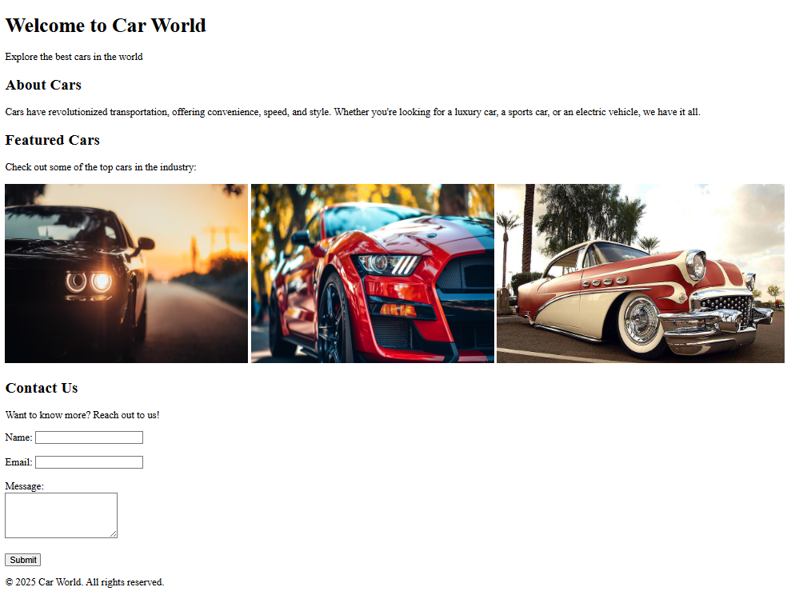

3 :

<!DOCTYPE html>

<html lang="en">

<head>

<title>Document</title>

</head>

<body style="display: flex; justify-content: center; align-items: center;" >

<form >

<lable for="name">Full Name</lable><br>

<input type="text" name="" id="name">

<br>

<lable for="email">Email</lable><br>

<input type="email" name="" id="email">

<br>

<lable for="male">Male</lable>

<input type="radio" name="gender" id="male">

<lable for="female">Female</lable>

<input type="radio" name="gender" id="female"><br>

<h5>Select your Class</h5>

<lable for="classIX">Class IX</lable>

<input type="radio" name="class" id="classXI">

<lable for="classX">Class X</lable>

<input type="radio" name="class" id="classX">

<h5>Select your Subjaects</h5>

<lable for="English">English</lable>

<input type="checkbox" name="" id="Englsh">

<lable for="Math">Math</lable>

<input type="Checkbox" name="" id="Math">

<lable for="science">Science</lable>

<input type="Checkbox" name="" id="science">

<lable for="evs">EVS</lable>

<input type="Checkbox" name="" id="evs"><br>

<div><lable for="feedback">Feedback</lable></div><br>

<textarea name="Feedback" placeholder="Feedback" id="feedback"></textarea><br>

<input type="button" name="SUbmit" value="Submit">

</form>

</body>

</html>

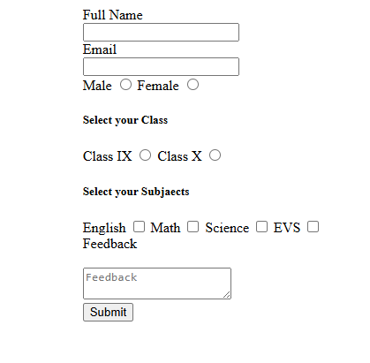

4 :

<!DOCTYPE html>

<html lang="eng">

<head>

<title>Document</title>

</head>

<body>

<header>

<nav>

<div class="nav1">

<img src="logo n.jpg" alt="logo" width="80vh h;" height="70vh" >

</div>

<div class="nav2">

<select name="Language" id="lang" style="background-color: rgb(80, 75, 75) ; color: aliceblue; height: 3vh; width: 10vh; border-radius: 10px; opacity: 0.6; font-size: small;" >

<option value="English"><b>English</b></option>

<option value="Hindi"><b>Hindi</b></option>

</select>

<button style="background-color: aliceblue; color: black; height: 3vh; width: 10vh;">Sign In</button>

</div>

</nav>

</header>

<div class="container1">

<div class="container2">

<h1 align="center"><big><b>Unlimited movies, TV <br>shows and more</b></big></h1>

<p align="center">Starts at ₹149. Cancel at any time.</p>

<h3>Ready to watch? Enter your email to create or restart your membership.</h3>

<div class="container5"><input type="email" id="email" placeholder="Email address"> <button id="bott2">Get Started &gt</button></div>

</div>

</div>

<div class="container3"> <h2><b>Trending Now</b></h2></div>

<div class="container4">

<span id="spn1"> <a href="./1.jpg" > </a><b>1</b> </span>

<span id="spn2"> <a href="./2.jpg" ></a><b>2</b> </span>

<span id="spn3"> <a href="./3.jpg" ></a> <b>3</b></span>

<span id="spn4"> <a href="./4.jpg" ></a><b>4</b> </span>

<span id="spn5"> <a href="./5.jpg" ></a> <b>5</b></span>

<span id="spn6"> <a href="./6.jpg" ></a><b>6</b></span>

</div>

<h1 style="color: aliceblue; margin-left: 8vh;">A plan to suit your needs</h1>

<div class="container6">

<div id="box1">

<h2>Mobile</h2>

<h4>480p</h4>

<img src="./check2.svg"> Fair video quality<br>

<img src="./check2.svg"> For your phone or tablet<br>

<br>

<h3>₹149 /mo</h3>

</div>

<div id="box2"> <h2>Basic</h2>

<h4>720p</h4>

<img src="./check2.svg"> Good video quality<br>

<img src="./check2.svg"> For your phone, tablet, laptop and TV<br><br>

<h3>₹199 /mo</h3> </div>

<div id="box3">

<h2>Standard</h2>

<h4>1080p</h4>

<img src="./check2.svg"> Great video quality<br>

<img src="./check2.svg"> For your phone, tablet, laptop and TV<br>

<br>

<h3>₹499 /mo</h3>

</div>

<div id="box4">

<h2>Premium</h2>

<h4>4k + HDR</h4>

<img src="./check2.svg"> best video quality<br>

<img src="./check2.svg"> Immersive sound(spatial audio)<br>

<img src="./check2.svg"> For your phone, tablet, laptop and TV<br>

<h3>₹649 /mo</h3>

</div></div>

<h1 style="color: aliceblue; margin-left: 8vh;">More resion to join</h1>

<div class="container7">

<div id="box71">

<h3> Enjoy on your TV</h3>

<p>Watch on smart TVs, PlayStation, Xbox,<br> Chromecast, Apple TV, Blu-ray players and

<br>more.</p>

<img src="./icons8-monitor-96.png" width="50px" height="50px" class="tv">

</div>

<div id="box72">

<h3>Download your shows to watch offline</h3>

<p>Save your favourites easily and always have

<br>something to watch.

</p>

<img src="./icons8-download-from-the-cloud-100.png" width="60px" height="60px" class="dow">

</div>

<div id="box73">

<h3>Watch everywhere</h3>

<p>Stream unlimited movies and TV shows on

<br> your phone, tablet, laptop and TV.</p>

<img src="./icons8-spaceship-100.png" width="60px" height="60px" class="ship">

</div>

<div id="box74">

<h3>Create profiles for kids</h3>

<p>Send kids on adventures with their favourite

<br> characters in a space made just for them —

<br> free with your membership.</p>

<img src="" width="" height="" class="smi">

</div></div>

<h1 style="color: aliceblue; margin-left: 8vh;">Frequently Asked Questions</h1>

<div class="container8">

<div id="l81"><h2>What is Netflix?</h2></div>

<div id="l82"><h2>How much does Netflis cost</h2></div>

<div id="l83"><h2>Where can I Watch</h2></div>

<div id="l84"><h2>How do I cancel?</h2></div>

<div id="l85"><h2>What can I watch on Netflix?</h2></div>

<div id="l86"><h2>Is Netflix good for kids?</h2></div>

</div>

<div class="cotainer9"></div>

</body>

</html>

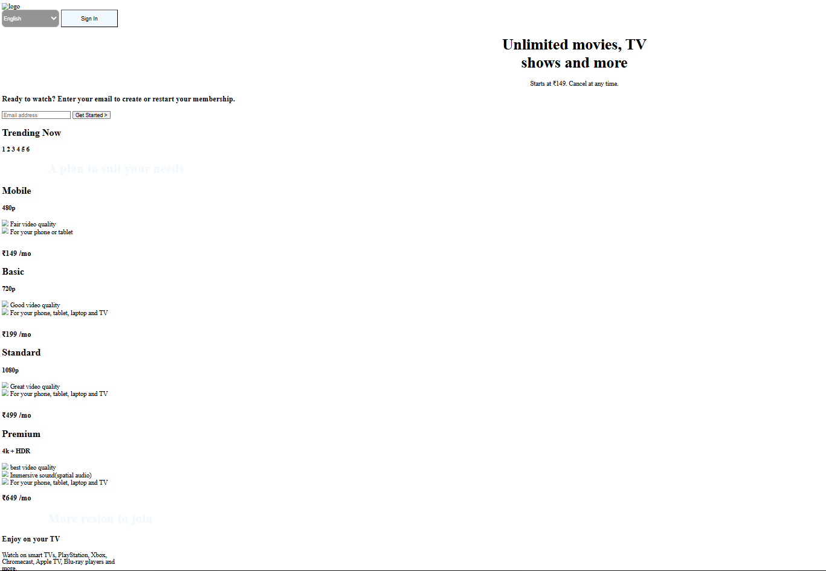

Final :

<!DOCTYPE html>

<html lang="en">

<head>

<title>Document</title>

</head>

<frameset rows = "25%, 25% " cols = "40%, 60%">

<frame src="C:\Users\acer\Desktop\Developer\link.html"></frame>

<frame src="C:\Users\acer\Desktop\Developer\Gitesh.html"></frame>

<frame src="C:\Users\acer\Desktop\Developer\skills.html"> </frame>

<frame src="C:\Users\acer\Desktop\Developer\index.html"></frame>

</frameset>

</html>

**Output :**

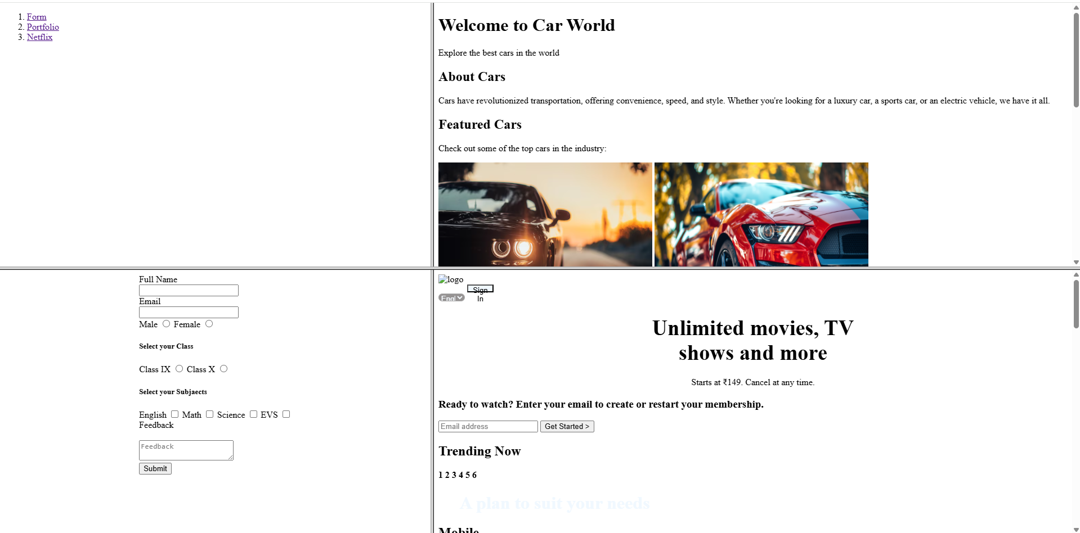

**Practical – 05**

**⁠Create a web page to show the college record in the form of a table. :**

<!DOCTYPE html>

<html lang="en">

<head>

<title>Document</title>

</head>

<body>

<table border="1">

<tr >

<h1>Students Fees Details</h1> </tr>

<tr>

<th>S.no</th>

<th>Name</th>

<th>Course</th>

<th>Fees Paid</th>

<th>Toltal</th>

</tr>

<tr>

<td>01</td>

<td>Anmol</td>

<td>BCA</td>

<td>15000</td>

<td>20000</td>

</tr>

<tr>

<td>02</td>

<td>Abhinav</td>

<td>BFA</td>

<td>20000</td>

<td>50000</td>

</tr>

<tr>

<td>03</td>

<td>Nitish</td>

<td>BCA</td>

<td>12000</td>

<td>20000</td>

</tr>

<tr>

<td>04</td>

<td>Abhishak</td>

<td>BBA</td>

<td>20000</td>

<td>30000</td>

</tr>

<tr>

<td>05</td>

<td>Aryan</td>

<td>BA</td>

<td>12000</td>

<td>18000</td>

</tr>

</table>

</body>

</html>

**Output :**

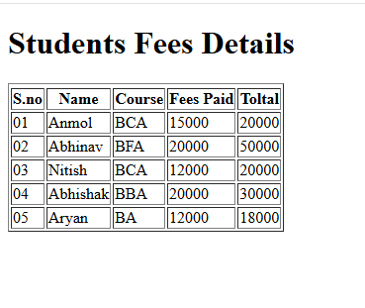

**Practical – 06**

**Write an HTML code to add internal CSS on a web page. :**

<!DOCTYPE html>

<html lang="en">

<head>

<title>Document</title>

<style>

body {

display: flex;

justify-content: center;

align-items: center;

background-repeat: no-repeat;

background-size: cover;

background-image: url( )

}

#div1 {

margin-top: 250px;

height: 400px;

width: 500px;

border: 2px, solid;

font-size: large;

display: flex;

justify-content: center;

align-items: center;

border-radius: 15px;

color: aliceblue;

}

h1 {

display: flex;

justify-content: center;

}

#div2 {

display: flex;

gap: 20px;

align-items: center;

}

#email {

border-radius: 10px;

height: 28px;

width: 300px;

border-color: aliceblue;

border: 1px, 1px, 1px, 1px;

color: rgb(0, 0, 0);

font-size: large;

}

#password {

border-radius: 10px;

height: 28px;

width: 300px;

border-color: aliceblue;

border: 1px, 1px, 1px, 1px;

color: rgb(3, 3, 3);

font-size: large;

}

button {

border-radius: 10px;

height: 35px;

width: 300px;

border-color: aliceblue;

border: 1px, 1px, 1px, 1px;

color: rgb(3, 3, 3);

font-size: large;

}

p {

margin-left: 20px;

}

</style>

</head>

<body>

<div id="div1">

<form action="">

<div>

<h1>LOGIN</h1>

<br>

<input type="text" placeholder="Email" id="email"><br><br>

<input type="password" placeholder="Password" id="password"><br></div>

<div id="div2">

<input type="checkbox" name="remindme" id="re">Remind Me

<p>Forget Password?</p></div>

<button>LOGIN</button>

<p>Don't have an account ? <a href="#">Register</a></p>

</form>

</div>

</body>

</html>

**Output :**

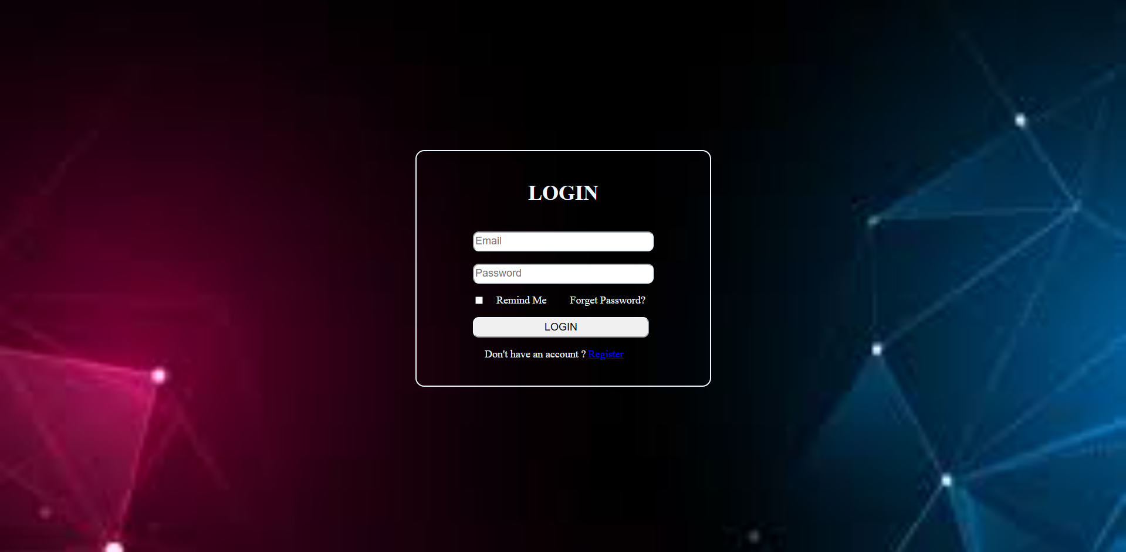

**Practical – 07**

**Design a blog- style personal website. :**

<!DOCTYPE html>

<html lang="en">

<head>

<title>Document</title>

<style>

header{

background-color: rgba(255, 242, 224, 0.616);

}

#name{

color: rgb(11, 12, 12);

display: flex;

justify-content: center;

align-items: center;

font-family: cursive;

margin-top: 50px;

}

nav{

display: flex;

justify-content: space-around;

align-items: center;

}

#div1{

display: flex;

list-style: none;

gap: 5px;

float: left;

}

#log1{

height: 20px;

width: 20px;

}

#log2{

height: 25px;

width: 25px;

margin-left: 50px;

}

#div2{

height: 30px;

border: 1px;

display: flex;

text-decoration: none;

list-style: none;

margin-top: 5px;

gap: 50px;

}

#div3{

float: right;

}

hr{

border-color: rgba(255, 254, 254, 0.3);

}

a{

text-decoration: none;

color: rgb(0, 0, 0);

font-size: large;

}

#div4{

display: flex;

justify-content: center;

align-items: center;

}

pre{

font-family: 'Times New Roman', Times, serif;

}

.my{

height: 500px;

width: 1500px;

border-style: solid;

border-color: rgba(39, 39, 39, 0.171);

font-size: xx-large;

font-family: 'Times New Roman', Times, serif;

background-color: rgba(255, 242, 224, 0.616);

}

.my1{

height: 750px;

width: 1500px;

border-style: solid;

border-color: rgba(39, 39, 39, 0.171);

font-size: xx-large;

font-family: 'Times New Roman', Times, serif;

background-color: rgba(255, 242, 224, 0.616);

}

.my2{

height: 680px;

width: 1500px;

border-style: solid;

border-color: rgba(39, 39, 39, 0.171);

font-size: xx-large;

font-family: 'Times New Roman', Times, serif;

background-color: rgba(255, 242, 224, 0.616);

}

.my3{

height: 750px;

width: 1500px;

border-style: solid;

border-color: rgba(39, 39, 39, 0.171);

font-size: xx-large;

font-family: 'Times New Roman', Times, serif;

background-color: rgba(255, 242, 224, 0.616);

}

.my4{

height: 250px;

width: 1500px;

border-style: solid;

border-color: rgba(39, 39, 39, 0.171);

font-size: medium;

font-family: 'Times New Roman', Times, serif;

background-color: rgba(255, 242, 224, 0.616);

}

</style>

</head>

<body>

<header>

<h1 id="name">My Written Story</h1>

<nav>

<div id="div1">

<li><a href="#"><img src="https://img.icons8.com/?size=50&id=A4DsujzAX4rw&format=png" alt="X" id="log1"></a></li>

<li><a href="#"><img src="https://img.icons8.com/?size=24&id=3864&format=png" alt="g+" id="log1"></a></li>

<li><a href="#"><img src="https://img.icons8.com/?size=50&id=8808&format=png" alt="linkedin" id="log1"></a></li>

<li><a href="#"><img src="https://img.icons8.com/?size=50&id=37326&format=png" alt="youtube" id="log1"></a></li>

</div>

<div id="div2">

<li><a href="#">Home </a></li>

<li><a href="#">About</a></li>

<li><a href="#">Videos</a></li>

<li><a href="#">Reviewas</a></li>

<li><a href="#">Contact</a></li>

</div>

<div id="div3">

<a href="#"><img src="https://img.icons8.com/?size=50&id=132&format=png" alt="search" id="log2"></a>

</div>

</nav>

<hr>

</header>

<br>

<br>

<div id="div4">

<div class="my">

<h1 style="justify-content: center;display: flex;">Welcome to My World!</h1>

<pre style="display: flex; justify-content: center;">Hey there! I’m Gitesh, and this is my little corner of the internet. I

write about the things I love, the stuff I’m learning, and the experi-

ences that shape me. Whether you’re here for inspiration, curiosity,

or just to pass the time—I'm glad you stopped by.

🌱 Life. 💻 Tech. ✈️ Travel. ☕ Random musings.

Dive in and explore! You never know what might resonate.</pre>

</div>

</div>

<br>

<div id="div4">

<div class="my1">

<h1 style="justify-content: center;display: flex;">👤 A Little Bit About Me</h1>

<pre style="display: flex; justify-content: center;"> I'm Gitesh, a BCA student based in Karnal. When I’m not working on

my schedule, you’ll find me writting some silly blos. This blog is a

space where I share stories, lessons, and personal takes on things that

matter to me—big or small.

Here’s some quick trivia:

💼 Day job: College

🎯 Passion: Full Stack Development

📚 Current obsession: [book/topic/show]

☕ Coffee order: [your go-to drink]</pre>

</div>

</div>

<br>

<div id="div4">

<div class="my2">

<h1 style="justify-content: center;display: flex;">✍️ Sample Blog Post 1: Life Update</h1>

<pre style="justify-content: center;display: flex;">Life's been a whirlwind lately! Between juggling work and trying to carve out some

"me time," I’ve learned a lot about slowing down and being present.

Some recent wins:

Started journaling daily 📓

Learned how to make legit sourdough 🥖

Finally took that road trip I’ve been dreaming about 🚗

If you’re going through a busy season too—take a breath. You’re doing great.

</pre>

</div>

</div>

<br>

<dvi id="div4">

<div class="my3">

<h1 style="justify-content: center;display: flex;">💻 Sample Blog Post 2: Tech Thoughts</h1>

<pre style="justify-content: center;display: flex;">Side projects are more than just fun—they’re a way to learn, experiment,

and stay curious.

Recently, I built a [brief description of a side project], and it reminded me

why I fell in love with coding in the first place.

Here's what I learned:

💡 Don't wait for perfect—just start

🛠️ Build small and iterate

🤝 Share your work, even if it’s not “done”</pre>

</div>

</dvi>

<br>

<footer>

<div id="div4">

<div class="my4">

<h3 style="margin-left: 12px;"> 📬 Contact :</h3>

<pre style="margin-left: 12px;">Got a question, comment, or just want to say hi? I’d love to hear from you.

📧 Email me at: <a href="mailto: giteshneg@hmail.com">giteshneg5@gmail.com</a>

💬 Or reach out on <a href="https://wa.link/s613t2">WhatsApp</a></pre>

<br>

<hr>

<p style="justify-content: center;display: flex;"> &#169; Made By &#x2665;&#xfe0f;. By Student Like You </p>

<hr>

</div>

</div>

</footer>

</body>

</html>

**Output :**

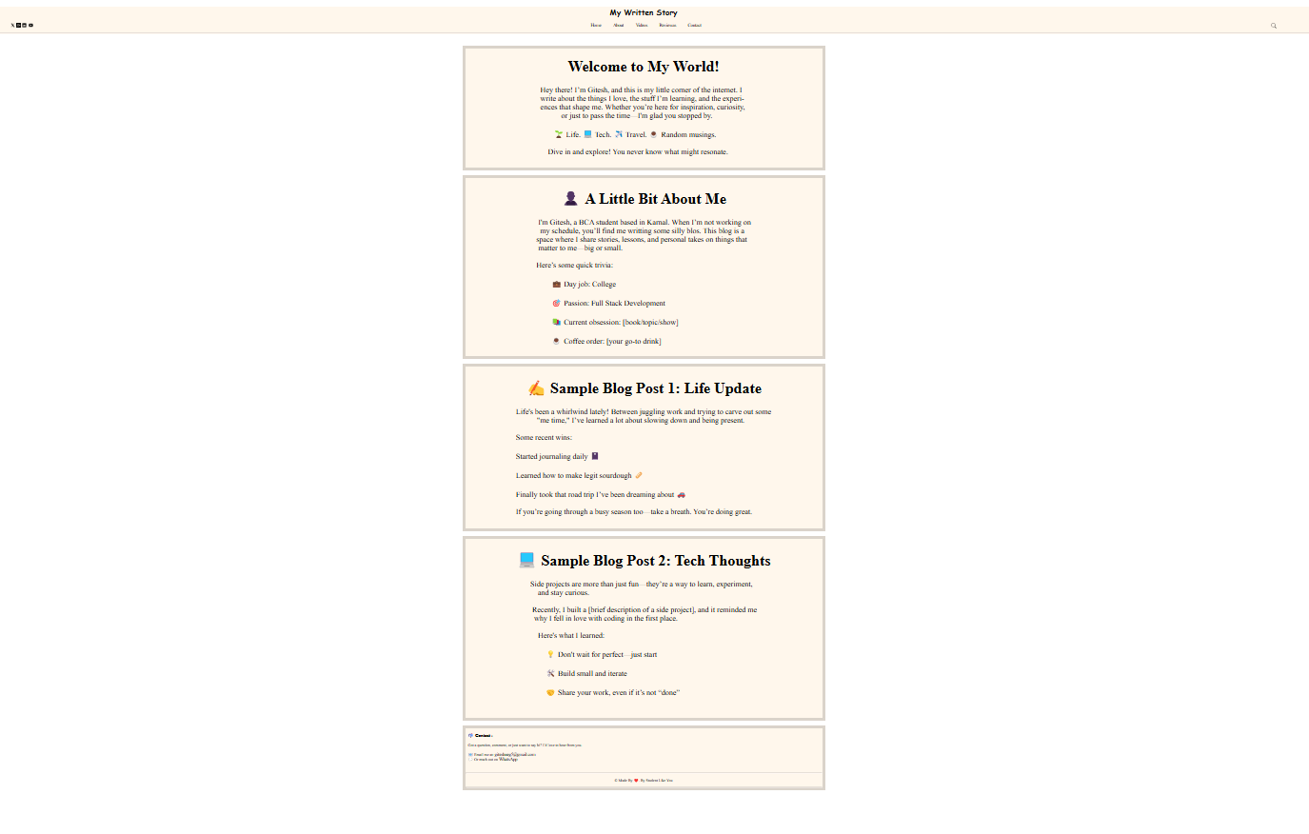

**Practical – 08**

**Write a CSS file and attach it to any 3 HTML webpages. :**

1:

<!DOCTYPE html>

<html lang="en">

<head>

<title>Document</title>

<link rel="stylesheet" href="./ass8.css">

</head>

<body>

<div id="div1">

<div id="div2">

<h1>“The Lost Map”</h1>

<pre>Liam found an old map in a secondhand bookstore in Venice.

It led him through winding alleys to a tiny courtyard with

no name, where a quiet woman served the best pasta he’d ever

tasted. She never charged him. When he tried to return the next

day, the courtyard was gone—and so was the map.</pre>

</div>

</div>

</body>

</html>

2 :

<!DOCTYPE html>

<html lang="en">

<head>

<title>Document</title>

<link rel="stylesheet" href="./ass8.css">

</head>

<body>

<div id="div1">

<div id="div2">

<h1>“Midnight at Petra”</h1>

<pre>At midnight, the tour group had long gone. Ravi stayed behind,

hiding in the shadows. When the moon rose, the rose-colored stone

of Petra glowed. He swore he heard ancient whispers and saw

figures dancing through the carved arches. He left before dawn,

changed and silent.

</pre>

</div>

</div>

</body>

</html>

3 :

<!DOCTYPE html>

<html lang="en">

<head>

<title>Document</title>

<link rel="stylesheet" href="./ass8.css">

</head>

<body>

<div id="div1">

<div id="div2">

<h1>“Wrong Train, Right Place”</h1>

<pre>Ella boarded the wrong train in Tokyo. She didn’t speak the

language, had no signal, and panicked. An old man noticed, smiled,

and motioned for her to follow. He led her to a quiet mountain

town, where she stayed a week, learned to make soba, and forgot

she was ever lost.</pre>

</div>

</div>

</body>

</html>

**Output :**

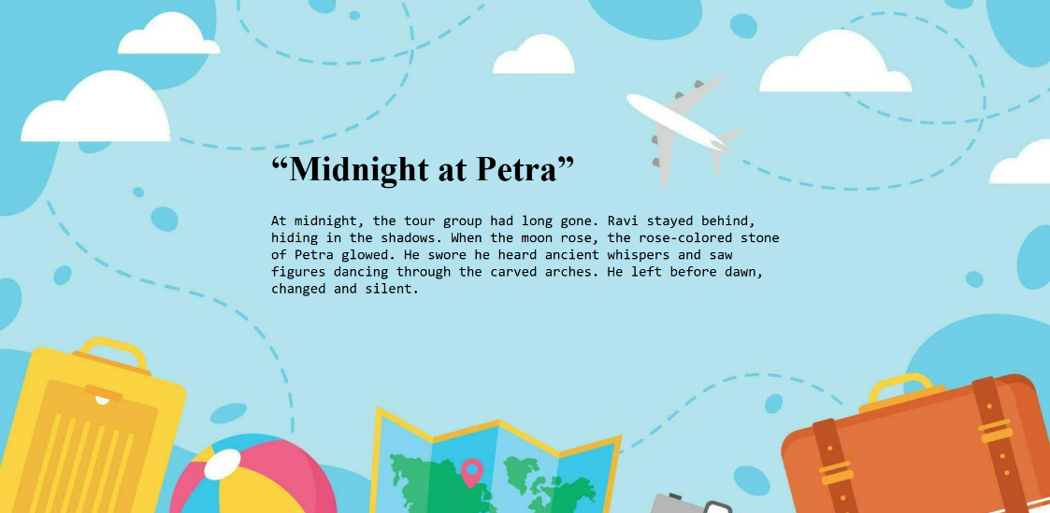

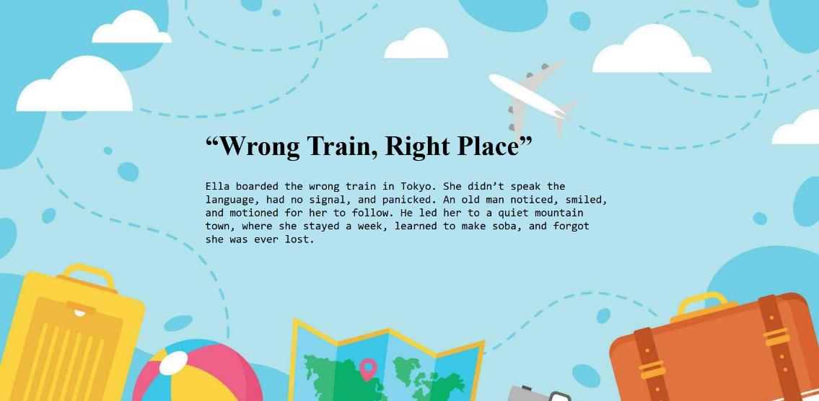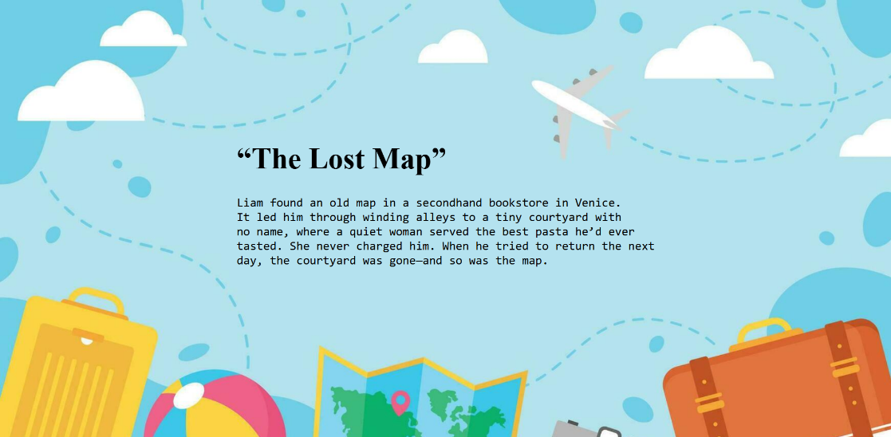

**Practical – 09**

⁠**Design a web page that is like a compose page of e- mail. It should have:**

* **Text boxes for To, CC and BCC respectively.**
* **Text field for the message.**
* **Send button.**
* **Options for selecting a file for attachment.**

<!DOCTYPE html>

<html lang="en">

<head>

<meta charset="UTF-8">

<meta name="viewport" content="width=device-width, initial-scale=1.0">

<title>Document</title>

<style>

*{

font-family: Arial, Helvetica, sans-serif;

font-size: large;

}

#nav{

gap: 8px;

}

div{

display: flex;

justify-content: space-between;

align-items: center;

}

input{

width: 850px;

height: 18px;

border: none;

outline: none;

}

textarea{

width: 1880px;

border: none;

outline: none;

margin-left: 5px;

resize: none;

overflow: hidden;

}

p{

display: inline;

}

#sub{

height: 20px;

}

#com{

height: 700px;

}

</style>

</head>

<body>

<div>

<div><a href="#"><img src="https://img.icons8.com/?size=32&id=14917&format=png" alt="back"></a></div>

<div id="nav">

<a href="#"><img src="https://img.icons8.com/?size=32&id=16028&format=png" alt="Attachmenta"></a>

<a href="#"><img src="https://img.icons8.com/?size=24&id=85940&format=png" alt="Send"></a>

<br>

<a href="#"><img src="https://img.icons8.com/?size=24&id=84119&format=png" alt="Menu" ></a>

</div>

</div>

<hr>

<p>From :</p> <input type="email" >

<hr>

<details><summary><p>To :</p> <input type="email"></summary>

<hr>

<p> Cc :</p><input type="email"><br><hr> <p>Bcc :</p><input type="email" >

</details>

<hr>

<textarea name="Subject" placeholder="Subject" id="sub" rows="1"></textarea>

<hr>

<textarea name="Compose email" id="com"></textarea>

</body>

</html>

**Output :**

